

Emergency & Safety
Procedures
Immediate Emergency Action:
In a Life-Threatening Emergency- Dial 911
- Protect Yourself First- Create and Manage Distance and Shielding from Threats Generally, the farther you move away from a threat, and the more solid and stable objects that you position between you and a threat, the safer you are from that threat.
- Calling 911
  - Give your name, location, and phone number
  - Describe the nature of the incident and its location.
  - Describe any injuries, weapons, hazards, devices, and property involved.
  - Describe the people involved, where they are, and where they went.
  - Stay on the line with the Dispatcher until help arrives.
  - Keep the Dispatcher updated on any changes so responding units can be updated.
  - Even if you cannot communicate, keep the line open.
  - The dispatcher may be able to learn more about what is happening.

Updated: June 18, 2026
DeAndra Busby- Theatre Manager
Gadsden State Community College
“Survival is not defined solely as getting through the immediate emergency…” -ARMA International

TABLE OF CONTENTS

Introduction ……………………………………………………………………………………………………………….....………… 3
Policy Statement ………………………………………………………………………………………………………….....……….., 4
Emergency Coordinators & Action Teams …………………………………………………………………………..……..........….. 5
Risk Assessment & Checklist ………………………………………………………………………………………………........….... 6
Communications Plan & Sample Press Release ………………………………………………………………….…………........... 9
Training Program …………………………………………………………………………………………………..………….….….. 11
Plans:
- Fire/False Alarm ………………………………………………………………………………………….…........ 13
- Severe Weather …………………………………………………………………………………………….…….. 15
- Evacuation Procedures for persons with disabilities ……………………………………………..…………..... 17
- Power Outage …………………………………………………………………………………...……….....…… 18
- Medical Emergencies: Staff, Performer, or Patrons ………………………………………………...………...... 20
- Winter Storm ……………………………………………………………………………………...….…….……. 21
- Bomb Threat …………………………………………………………………………………...………..……..... 22
- Explosion ……………………………………………………………………………………...…………….....… 23
- Flooding and Water Damage ………………………………………………………………...………………...... 24
- Missing Child ………………………………………………………………………………………………..…….. 25
- Crime or Violent Behavior ……………………………………………………………………………................. 26
- Hostile Intruder ……………………………………………………………………………..………................... 27
- Pandemic: Shut down and re-opening guide ............................................................................................................. 28
Appendix A: Exit Ground Plans ……………………………………………………………………………................................... 33
Appendix B: Fire Extinguisher Locations ……………………………………………………………………………...…………..... 35
Appendix C: Shelter Locations …………………………….………………………………………………….............................. 36
Appendix D: Calling Chain & Important Phone Numbers …………………………………………………….............................. 37
Appendix E: First Aid Care ………………………………………………………………………………………………..…….…… 38
Appendix F: Incident Report …………………………………………………………………………......................................... 40
Appendix G: Staff Emergency Contact …………………………………………………………...………………………...………. 41
Resources …………………………………………………………………………………………………………………………… 42

INTRODUCTION
Mission Statement
The mission of the Wallace Hall Fine Arts Center at Gadsden State Community College (GSCC) is to serve as a meeting place for the community to engage in educational opportunities and enhance understanding and enjoyment of life through the creation and presentation of high-quality performing and visual arts.

Staff Size:
One (1)Full Time Staff, ten (10) Part Time Staff, ~Twenty (20) Volunteers (Event Services and Volunteers are used for Event Staff and other programming activities as needed). Wallace Hall is owned and operated by Gadsden State Community College, part of the Alabama Community College System.

Operating Budget:
N/A

Facility Description:
Address:
Physical Address: Mailing Address:
Wallace Hall Fine Arts Center Wallace Hall Fine Arts Center
1001 George Wallace Drive P.O. Box
Gadsden, AL 35903 Gadsden, AL 35903

The Wallace Hall Fine Arts Center is located on the Wallace Drive Campus of Gadsden State Community College. Construction began on the Wallace Hall Fine Arts Center in January 1967. The $1.5m (1968) building was designed by Architects Hofferbert & Ellis. The center was built with excellent acoustics and modern stage equipment. Upon completion, the center hosted performers from around the globe with the Callan Concert Series.
By 1997, the near constant use of the Hall had taken its toll. Without major renovations, the Hall would face closure. In 1998, however, Gadsden State and the City of Gadsden raised over $450,000 to complete the needed repairs. Over 1,200 new theatre seats were installed. The lobby restrooms were gutted and replaced. New dressing space was added along with a host of other facility improvements. In 2011, the Fine Arts Center received a landmark grant from the United States Department of Energy of over $150,000 to transform the theatrical lighting systems into more of an energy efficient, green system. The facility now boasts a LED (light emitting diode) lighting system which saves an estimated $35,000 in energy costs annually.
The Gadsden Live Performance Series was founded in 2012 as a consortium between Gadsden State, the Gadsden Cultural Arts Foundation, and The Gadsden Times newspaper. Gadsden Live was created to fill the void left behind when the Callan Concert Series ceased operations. The series launched in the winter of 2012 and will present four to six nationally touring performances annually.
In summer of 2013, Gadsden State Community College complete a comprehensive Facilities Master Plan which identified several key projects that will dramatically change the face of the Fine Arts Center. The proposed enhancements include a backstage annex to include a large rehearsal hall, dressing room space, storage, and scene shops; expanded restrooms, concessions, an box office facilities in the lobby; improved ADA access on the orchestra level and new ADA access to the balcony and gallery spaces; transformation of the courtyard into a sculpture garden which might also be used as pre-function event space for the theatre; a fully motorized theatrical fly system and updated electrical infrastructure. The master plan will be implemented in phases as funding becomes available.
Wallace Hall is currently completing it’s most recent renovation to gut and update the classroom side of the venue. Completion is anticipated for late summer 2026.

The Wallace Hall Fine Arts Center is a 55k square foot, state of the art performing arts venue that houses:
- 1,200 seat Main Stage Theatre
- The Mezzanine Art Gallery – a changing exhibit space located between the Orchestra and Balcony Seating Levels.

POLICY STATEMENT
The purpose of this plan is to provide resources so that informed decisions can be made.
The Wallace Hall Fine Arts Center’s Emergency Action Plan (EAP) is designed as part of our commitment to the safety and well-being of our artists, volunteers, employees, patrons, and community. This plan provides basic information so that the reader can be better prepared in the event of an emergency or critical incident. Our primary concern, in the event of an emergency, is to ensure the safety of all guests, performers, and staff members present, should an emergency occur. This Emergency Plan is not designed to give definitive answers for every type of emergency. Each incident is unique and constantly evolving. The purpose of this plan is to provide resources so that informed decisions can be made.
The Wallace Hall Fine Arts Center has systems and procedures in place to help the venue respond to all levels of emergency situations and recover from all natural and man-made emergencies promptly and effectively.
An emergency is any event, whether expected or unexpected, that places the life of an employee, performer, or guests or significant venue assets in danger, or threatens the ability to conduct normal business operations.
During an emergency the Theatre Manager (or in his/her absence, the Fine Arts Division Chair) has the responsibility and authority for activating the Emergency Action Plan. During an event or state of emergency, the Theatre Manager will work closely with GSCC officials and Chief of Police to activate the Emergency Plan
Our primary concern, in the event of an emergency, is to ensure the safety of all guests, performers, and staff members present. This emergency plan is not designed to give definitive answers for every type of emergency. Each incident is unique and constantly evolving. The role of the Wallace Hall staff is to provide up to date knowledge and confident guidance to coworkers, volunteers, event services, artists, independent contractors, and guests in the event of an emergency situation to ensure that as many persons as possible will maintain their health and safety at the conclusion of any emergency, big or small.
Once an emergency is in progress, immediate action is essential to minimize loss of life and property. The knowledge of proper procedures laid out in this plan is vital to properly handle the situation. Therefore, it is encouraged that all staff members familiarize themselves with the information in this plan prior to an occurrence and to review the information on a regular basis. Preparation is the most important step that anyone can take to minimize their risks during an emergency and ensure the execution and recovery of the venue during any emergency situation. Advanced planning and training for employees can save time when making decisions about what action to take during a critical situation. Individuals are responsible for their own safety first, and to prepare themselves for an emergency.
This plan will be reviewed, and updated as needed, on October 1 of each year. Additional changes will be made following the completion of any capital projects, major renovations, and will be revisited during the recovery after any emergency situation. All employees, volunteers, and Independent Contractors will be trained on how to handle emergency situations, will be involved with drills to assist in preparedness, and will be communicated in the event of any changes/updates to this plan.

EMERGENCY COORDINATORS
See Appendix D for Calling Chain
Our preparedness and response to emergency situations is centered around a number of teams as outlined below:
Primary Venue Contact & Emergency Planning Manager
- Theatre Manager

Emergency Preparedness Committee: This team consists of all department heads as listed below and are responsible for the planning, preparedness, and upkeep of this plan.

- Administration: Theatre Manager
- Operations: Theatre Manager
- Production: Technical Director
- Ticketing: Box Office Manager
- Volunteers: House Manager

Emergency Planning Committees:
- Disaster Team: When it appears that a threat to WALLACE HALL is likely the Disaster Team will be responsible for the areas listed next to their titles.
- The Theatre Manager or Chief of Police will activate the Emergency Plan
Alternate Disaster Team
Theatre Manager OR Division Chair
Technical Director OR Assistant Technical Director
Box Office Manager OR Assistant Box Office Manager
House Manager OR Box Office Manager
Division Chair OR Fine Arts Asst.
Primary Disaster Team & Responsible Areas
Theatre Manager – Staff/Employee Safety & Venue Safety
Technical Director – Back of House/Performer Safety
Box Office Manager – Front of House & Patron Safety
House Manager – Volunteer & Event Services Safety
Fine Arts Division Chair – Gallery & Collections Safety

After An Emergency:
- After an Emergency, the Disaster Team will enter the building along with the Recovery Team to survey the physical condition of the building and collections and begin to take the appropriate steps.
- The Theatre Manager & Structural Engineer will determine when it is safe for staff members and guests to enter the building.
Recovery Committee:
Theatre Manager Director of Operations Technical Director
Campus PD Representative Fire Marshall Structural Engineer

*ALL EMPLOYEES, VOLUNTEERS, AND INDEPENDENT CONTRACTORS WILL BE TRAINED IN EMERGENCY SITUATIONS AND WILL BE UPDATED IN THE EVENT OF ANY CHANGES/UPDATES TO THIS PLAN.
RISK ASSESSMENT
The following risk assessment is for The Wallace Hall Fine Arts Center at Gadsden State Community College, Etowah County, Alabama, and will focus mainly on natural environmental situations, but will not count out man-made emergency situations. This assessment is built from references from the GSCC Emergency Action Plan & Risk Assessment as well as the FEMA Mitigation Plan for Etowah County, and first hand experiences by the Wallace Hall Fine Arts Center team. These plans are available upon request. This risk assessment should be used to help ensure the safety of all WALLACE HALL guests, patrons, volunteers, staff, performers, and community.

Matrix Definition:
- Risk: The potential loss of life, injury, or destroyed and/or damaged assets that could occur as a function of hazard, exposure, vulnerability, and capacity.
- Frequency: The return period of any given hazard and its impacts based on a time scale outlined in the FEMA Mitigation Plan for Etowah County where the probability of occurrence is =80% or greater.

Risk Categories for the Wallace Hall Fine Arts Center- Detailed outline in this Emergency Action Plan
- Fire/False Alarm
- Severe Weather
- Winter Storm
- Bomb Threat
- Explosion
- Missing Child or Adult
- Flooding/Water Damage
- Power Outage
- Medical Emergencies during events
- Crime or Violent Behavior
- Hostile Intruder
- Pandemic

High Frequency/High Risk:
- Tornado: Severe thunderstorms can produce tornadoes that destroy anything in its path, resulting in loss of power, shelter, and potential loss of life, and interruption to sanitation and water delivery.
- High Winds/Wind Storm: High winds can cause downed trees and electrical lines resulting in loss of power.

Low Frequency/High Risk:
- Lawsuit: Has potential to negatively affect the GSCC community, not just the venue.
- Sudden Loss of Support/Income from key Revenue Streams/Donors: Would cause financial strain on the venue operations and production/programming capabilities.
- Missing Person/Child: Would be devastating to the GSCC community, not just the venue. Safety measures are in place for any persons under the age of 18 on-site.
- Negative Traditional Media Coverage/Controversial Social Media Reviews/Posts:
- Aging Infrastructure: Could cause anything from a minor inconvenience to a serious emergency.
- Bomb Threat: Though unlikely, would be devastating to the GSCC community, not just the venue.
- Civil unrest/Protests
- Death or other loss of Key personnel/board: Would cause grieving at the venue and affect the community as well.
- Hostage Situation: Would be devastating to the GSCC community, not just the venue. Safety measures are in place, such as silent alarms and check- in/sign-in systems.
- Active Shooter: Would be devastating to the GSCC community, not just the venue. Safety measures are in place, such as silent alarms and check- in/sign-in systems.
- Audio Equipment Malfunction
- Lighting Equipment Malfunction
- Electrical Equipment Malfunction (non-production)
- Data Breach/Software Malfunction/Virus: The venue uses PurplePass for ticketing, which is a encryption based online sales platform, the possibility of breach is <5%.
- Earthquakes: A highly unlikely event, that could cause property damage, underground infrastructure damage, building collapse, and possibly trigger other natural disasters. Buildings in Etowah County are not built to meet the rigors of earthquakes.
- Tsunamis: A highly unlikely event, that would be catastrophic to operations
- Snow/Ice Storm: Due to the infrequency of snow and ice storms in Etowah County, staff and guests are unprepared to navigate this type of risk due to widespread impassable roads, disruption of services and response capabilities, and crop and other agricultural damage.
- Pandemic: Will interrupt operations for the duration of the pandemic/infectious disease and will cause economic hardship for the venue.
- Theft: Could greatly affect operations and production.
- Major Medical Emergency (During an event): Would delay operations and possibly cause panic among patrons.
- Hurricanes/Tropical Storms: Can cause storm surges, high winds, heavy rains, spawn tornados, and cause inland flooding
- Harassment (External or Internal): Would have a significant impact to the reputation and operations of the venue.
- Arson/Vandalism: Would be devastating to the GSCC community, not just the venue. Safety measures are in place, such as silent alarms, security cameras and check- in/sign-in systems.

High Frequency/Low Risk:
- Thunderstorms/Lightning: Etowah County experiences many thunderstorms each year, mostly during the spring, summer, and late fall. Lightning can pose many threats to people and infrastructure and can ignite fires.
- Floods/Flash Floods: Heavy rains can produce severe storm water run-off in developed areas and cause bodies of water to breach their banks.

Low Frequency/Low Risk:
- Drought/Extreme Heat: Can cause crop and other agricultural damage, water supply shortage, increase vulnerability to forest fires, and can be debilitating to our community resulting in heat exhaustion, hospital stay, or even death.
- Hail: Large hail can injure people and livestock and damage crops.
- Landslides: May cause impassable roads.
- Wildfires: Unlikely, may cause loss of property and livestock, destruction of wilderness, crop destruction.
- Gas & Other flammable and combustible substance leaks: No gas or fuels are used or stored onsite
- Hostile Intruder/Suspicious Behavior: Would be devastating to the GSCC community, not just the venue. Safety measures are in place, such as silent alarms, security cameras, and check- in/sign-in systems.
- Breach of Contract: Could affect ability to work with unions, vendors, contractors, etc.
- Minor Injury: Team members and first responders are onsite to provide treatment until medical aid can be assessed, if needed.
- Dam Failure: Loss of life, destruction of property, unregulated water flow to surrounding areas, increased amount of disease and disease-carrying animals in the areas.
- Internet Failure/Malfunction: Though unlikely, this could affect ticket sales and certain production capabilities.

RISK ASSESSMENT CHECKLIST

 | Yes | No | Unsure
Are up-to-date emergency telephone numbers and/or addresses posted?
Is staff prepared to handle an emergency, including sounding an alarm and using fire extinguishers?
Is there an emergency supply inventory, and is it up to date?
Has the backup power supply been tested in the last year?
Are flashlights and batteries readily available?
Have alarm and fire suppression systems been tested recently?
Are emergency exits accessible?
Do all locks have keys nearby?
Are fire extinguishers fully charged and accessible?
Is electrical wiring in good condition?
Does a general institution wide cleanup take places on a semiannual basis, with the entire staff participating?
Are floors clear of wood shavings, paper, cloth, and other flammable materials?
Are walkways clear of debris?
Are heating and electrical system motors free of dust and clutter?
Are precautions in place and taken during construction, renovation, and repair?
Are up-to-date copies of important documents and records stored off-site?
Is the insurance provider aware of the emergency plan and of the institution’s probable maximum loss?
Are important collections stored away from windows and pipes?
Have elevators and automatic door closures been tested regularly in fire-response drills?
Are pipes and plumbing regularly checked for leaks?
Has the fire department visited the site in the last six months?
Are your building and grounds up to safety codes?
Are you prepared to handle a medical emergency?
Has staff been given any advice or training in home safety?
Are there hazards around the outside of the venue?
Do local police and fire have copies of the venue’s site plans, indicating location of utility mains and various kinds of extinguishers?
Have arrangements been made for use of off-site storage, dehumidifiers, and so on, if necessary during an emergency?
Has all staff, volunteers, independent contractors, etc. been training in the last six months?

Completed by: ____________________________ Date Completed:________

- To be completed by the Emergency Preparedness Committee (See page 6) in January and July of each year.
- Please make a copy of this form, the completed form should be turned in to the Emergency Planning Manager.

COMMUNICATIONS PLAN
CHAIN OF COMMAND
Primary Decision Maker & Media Spokesperson
DeAndra Kaye Busby- Theatre Manager
Alt: Division of Fine Arts Chair
Press & Social Media Writer
Austin Tillison- Marketing
Alt: Theatre Manager

During any situation the Theatre Manager has the responsibility and authority for activating the Emergency Action Plan. During an event or state of emergency, the Theatre Manager will work closely with GSCC officials and Chief of Police to activate the Emergency Plan
Appendix D: Calling Chain should be referenced for the appropriate release of information and tasks, either through phone calls, texts, Email, or Slack (internal communications app)
How to Contact:
- Phone Calls: Patrons, Volunteers, Performers, Board Members
- E-mail: Patrons, Volunteers, Board Members
- Slack: Staff
- Texts: Staff (if not reached via slack)

How to Report a Crisis/Incident:
- Call 911 IMMEDIATELY if a situation could lead to serious injury or death.
- Inform the Theatre Manager to initiate the Calling Chain (See Appendix D)
Communication with Media:
- The Theatre Manager and Director of PR will begin working on a press release.
- No employees, volunteers, etc. should speak with any media outlets or post any information on social media, unless appointed by the Theatre Manager
- Guests, patrons, event services, and board members are strongly discouraged from speaking with any media outlets or posting any information on social media, until the incident has been handled.
How to communicate with Emergency Responders:
- What happened?
- How large an area is affected?
- Are there any known path/doorway obstructions?
- Who is in the building? Guests? Staff? Persons with Special Needs?
- Where are the entrances and exits?
- What hazards are present and where?
- What location is good for a staging area?
- What response has already taken place?
- What and where are the priority materials?
After an Emergency/Recovery Team:
- What agencies were worked with and what discussion was successful and what was not?
- What could go better? What went well?
- Update Emergency Plan
Cancellation Policy for Events:
Whenever the City of Gadsden has officially closed all streets for severe weather or other situations, performances will be cancelled, and the venue’s offices will be closed. Performances may be cancelled under extreme conditions at other times. The Theatre Manager and oxford Police Department will make the decision regarding the cancellation of a performance at least 2 hours prior to the scheduled curtain time. Upon a decision to cancel a performance and/or the closing of the venue’s offices, the calling chain shall be activated.

SAMPLE PRESS RELEASE

Wallace Hall Fine Arts Center
Date: January 1, 1990
CC: Mario Gallardo, Divison of Fine Arts Chair
Dr. Derrick Griffey, Dean Academics & Programs

Spokesperson: DeAndra Kaye Busby, Theatre Manager - Wallace Hall Fine Arts Center

FOR IMMEDIATE RELEASE

*Do not involve the value of damaged or destroyed objects. Avoid taking blame*

The Wallace Hall Fine Arts Center at Gadsden State University is aware of the current situation and is currently cooperating with the appropriate authorities and has initiated its emergency response plan. (Brief explanation of what happened, why & how it happened (if known), when and where did it take place, who was involved)
Our team of trained personnel is currently on-site working as quickly as possible to resume normal operations.
We understand the concerns, fears, and questions you may have about the incident that took place (time frame.)
At this time, we are doing everything that we can to correct this situation and to prevent or minimize its recurrence.
(List specific steps that WALLACE HALL is taking)
The safety and well-being of our staff, patrons, and community is our first priority.
We will continue to inform the media of any additional information through our website: oxfordpac.org.

TRAINING PROGRAM
This Training Program is for the following stakeholders/persons:
- Full-Time Employees
- Part- Time Employees
- Independent Contractors
- Event Services
- Volunteers
- Board members
- Rental Events
- Artists & Performers
Measurements of Success:
If during a drill or training exercises all information is explained and carried out within a specified time limit
- Prior to Drills and Training there will be a fifteen-minute open conversation to discuss the details and make clear the objective and goals for the training, and to answer any questions. This time limit may be extended as needed.
- After Drills and Training Stakeholders will complete one (or more) of the following:
  - Survey Feedback/Comment Card
  - Debrief Discussion
  - The Facilitator/Trainer will join the Emergency Planning Committee after the training is completed to share their observations.
Emergency Plan updates: See Emergency Coordinators <page number>
- The Emergency Planning Manager will be responsible for making all updates and changes to the emergency plan.
- Emergency Planning Manager will distribute any emergency plan updates to the Emergency Preparedness & Emergency Planning Committees:
  - After each training and drill session
  - After any emergency situation/incident
  - At the completion of any renovations/updates to the venue
    - If emergency exits are changed during these processes, updates will be issued to all stakeholders and committees IMMEDIATELY
  - After the annual review (October 1 of each year)
- Updates may include but (are not limited to):
  - Measurements of success from drills/training
  - Feedback and comment cards from stakeholders & facilitator/trainer
  - Any renovations that change the layout or emergency plan for the venue
Options for training/drilling:
- Role play drills with staff
- Self-assessment exercises
- Staff discussions
- Classroom presentation
- Printed materials: brochures, newsletters, booklets
- Online: emails or websites
- Unplanned mock emergency drills
- Simulations
- Workshops with GSCC PD
  - Special needs persons during emergencies
  - Basic First Aid and CPR
Type of Exercise | Emergencies Addressed | Resources/Contacts Needed | Time of Year/Date | Persons to Attend | Incentive/Notes
Evacuation Drill  (Business Day) | Bomb, Fire, Explosion, Power Outage | Fire Department  Police Department  Safety Representative | Annually - August | Full-Time Staff  Part-Time Staff  Board Members | Task & Responsibilities will be communicated/refreshed for all staff members
Evacuation Drill  (Event Day) | Bomb, Fire, Explosion, Power Outage | Fire Department  Police Department  Safety Representative | Twice Yearly  During Volunteer Training – September & April | Full-Time Staff  Part-Time Staff  Board Members  Volunteers  Event Services  Independent Contractors | Dinner will be provided for all participants.
Shelter in Place | Severe Weather | Fire Department  Police Department  Safety Rep | Twice Yearly  During Volunteer Training – September & April | Full-Time Staff  Part-Time Staff  Board Members  Volunteers  Event Services  Independent Contractors | Dinner will be provided for all participants.
Medical Emergency | Medical Emergency | Fire Department  EMS | TBD | Full-Time Staff  Part-Time Staff | Inventory first-aid kits
Lock Down | Missing Child  Hostile/Violent Intruder  Suspicious Activity  Hostage Situation | Police Department | TBD | Full-Time Staff  Part-Time Staff  Board Members  Volunteers  Event Services  Renters  Independent Contractors | TBD
Procedures: | Reviews | In-house | Annually- October | Full-Time Staff  Part-Time Staff | Opening/Closing of Venue  Alarms  Security Cameras  How to report an emergency  Safe/Keys  Alarmed Areas  Passwords
Training & Drilling Schedule:
Important Notes:
- Training sessions should be announced to stakeholders a minimum of two weeks (14 total days) prior to the scheduled training/drill
- There will be an OPT-OUT option for anyone uncomfortable with the subject matter covered in the training. These persons will be given reading materials to cover any need-to-know information.

FIRE
See Appendix B for Fire extinguisher locations.
- Remain Calm.
- Notify the Manager on Duty who should call the Gadsden Fire Department IMMEDIATELY (911)
- Pull the nearest fire alarm
- Notify others in the building via Slack or in person given proximity.
- Close doors to unoccupied rooms
- If the fire is small, attempt to put it out yourself in the appropriate manner (see table below). Do not jeopardize your personal safety.
- Never allow the fire to come between you and the exit (i.e. If the fire is between you and the nearest exit choose an alternate way out of the building.)
  - LARGE FIRE: Evacuate the building immediately
  - SMALL FIRE: follow the steps below
    - Disconnect electrical equipment that is on fire only if it is safe to do so.
    - Evacuate the area if you are unable to put out the fire. Close doors and windows behind you to confine the fire. Move a safe distance away from the building (parking lot or across the street) and account for the people in your department ASAP.
    - Do not break windows. Oxygen feeds fire.
    - Do not open hot doors. Before opening ANY door, touch near the top. If the door is hot or if smoke is visible, do not open the door.
    - Do not attempt to save possessions at the risk of personal injury.
- Theatre Manager, Division of Fine Arts Chair, and Technical Director will do a sweep through the seating areas, offices, and restrooms after evacuation if it is safe and prudent to do so, after first responders have given the “all clear”
- Do not return to the emergency area until instructed to do so by Police or Fire Department.
Description of Fire | Suitable Suppression/Type of extinguisher
Class A: Solid materials such as wood, paper, cloth, etc. | Foam, Water, Wet Chemical, Dry Powder
Class B: Flammable Liquids such as petrol, oil, diesel, etc. | Foam, Carbon Dioxide
Class C: Flammable Gases such as propane, butane, etc. | Dry Powder
Class D: Metals such as aluminum, magnesium, titanium, etc. | L2 & M28 Powder
Class E: Electrical Fires such as lamp, computer, etc. | Carbon Dioxide, Dry Powder
Class F: Cooking oils and fats | Wet Chemical
The person who calls 911 is responsible for informing the fire department upon arrival a rundown of the situation, any potential hazards in the building (I.e. open pit, fire location, etc.), and if anyone is stuck in the building.
Large Fire Evacuation: Designated Safety Areas:
If during an event:
See Appendix A for Evacuation Routes
- Manager on Duty, House Manger, and Campus PD will work together to make the call "Please evacuate the building”, staff members will immediately begin assisting first responders in the event of an evacuation.
- All on-stage activity shall cease immediately and without hesitation.
      - The Stage Manager or Fly Operator will announce from the stage that we are going to evacuate everyone by reading the following script

“The building will now be evacuated due to the potential of a fire; we have been advised by safety officials to evacuate the venue. We have sufficient time to calmly and carefully proceed to the designated safe areas outside of the building. Please remain calm, in your seat, and listen carefully as we provide detailed instructions.
        - If you have a disability and need assistance getting to your safe area, please remain in place and raise your hand, if possible. A staff member or first responder will aid you quickly.
        - All guests seated in the Odd Number Seating Section will exit out the House Left Exit Door (Performer Door to Grass Area). A staff member will lead you to your designated safe area. (Lead to Dorms)
        - All guests seated in the Even Number Seating Section will exit out the Main Lobby door (Head across the street A staff member will lead you to your designated safe area.
        - All guests seated in the 100 Seating Section will exit out the House Left Theatre Manager Office Door (Head backwards to the Dorms/Grass Area). A staff member will lead you to your designated safe area.
        - All guests seated in the balcony Sections will exit down the stairwells and out the Main Lobby & Side Doors
        - Artist/Performers and technicians will exit through the back-loading dock and breezeway to the Dorms”
      - Audio Tech, Lighting Tech, and MOD will do a sweep through the seating areas, offices, and restrooms after evacuation if it is safe and prudent to do so.
One Staff member and a volunteer, if possible, should remain with patrons outside at each “Evacuation Station”
If evacuation is not possible:
- In a fire or fire alarm situation, always check doors to see if they are hot or warm to the touch before opening them. If heat or smoke prevents you from evacuating, find the nearest stairwell and secure the doors as much as possible. All stairwell doors in the Wallace Hall Fine Arts Center are fire doors that will slow the spread of the fire. Immediately call 911 and advise them of your location and situation.
Recovery:
At the completion of the incident, the Fire Department (or other appropriate emergency response official(s)) will release the building to the Theatre Manager and communicate whether the facility is all clear, or clear with conditions for re-occupancy. The Theatre Manager will communicate with the Recovery Team and other employees to determine the next phases to include: re-occupancy for patrons/guests, damage assessment, re starting a performance, etc.
False Alarms:
- Theatre Manager shall call Security Company (ADS Security) at (800) 866-4860 to tell them it is a false alarm, ASAP
- Perform a building-wide page to convey that the alarm was false

SEVERE WEATHER
Theatre Manager, or Manager on Duty, monitors weather conditions and will notify via Slack or Loudspeakers through-out the building of weather dangers and warnings when they are a threat.
- Remain Calm
- Stay away from exterior walls and glass.
- Proceed to your designated safety area. If you are unable to get to a lower level, crouch down along interior walls and cover your head.
- Staff, artists, and technicians should proceed to the On Stage Dressing room. Patrons in the theatre will be advised to remain in their seats until they are able to be ushered to their Safety Area.
- When assisting the public:
  - Ask people to move
  - Warn them of danger
  - If they refuse to move, leave them
  - Be polite but firm
- Do not leave secure areas until instructed to do so.
- After the tornado strikes or the threat is over:
  - Staff will organize a search throughout the building to assess any injury or hazardous situations in the building. If necessary, call 911.
  - First Aid will be administered as necessary.
  - Staff will direct emergency response personnel to those needing assistance.
- Manager on Duty or emergency responders will advise when the “all clear” has sounded.
Designated Safety Areas:
If during an event:
Assess weather conditions two hours before the beginning of each event. If severe weather is expected, the Box Office Manager should relocate the Weather Radio to the Box Office.
- Manager on Duty, House Manger, and PD will work together to make the "Shelter in Place” call. Staff members will immediately begin assisting first responders in the event of an evacuation.
- All on-stage activity shall cease immediately and without hesitation.
- The House Stage Manager or Fly Console Operator will read the following aloud over the sound system (via wireless mic from the stage):
“The building is now under a Tornado Warning; we have been advised by safety officials to Shelter in place. We have sufficient time to calmly and carefully proceed to the designated severe weather shelter stations. Please remain calm, in your seat, and listen carefully as we provide detailed instructions.
      - If you have a disability and need assistance getting to your designated shelter area, please remain in place and raise your hand, if possible. A staff member will aid you quickly.
      - All guests seated in the balcony should proceed calmly to the exit stairway nearest you on the left and right side of the balcony. A staff member will lead all guests in the balcony to your designated shelter location in the classroom Hallways
      - All guests seated in the left orchestra section, Center Orchestra Section, and Right Orchestra Section, a staff member will lead you to your designated shelter location in the band and choir room hallways.
      - Artist/Performers and technicians will shelter in the Green Room/Artist Hospitality Room with doors secured”
Audio Tech, Lighting Tech, and MOD will do a sweep through the seating areas, offices, and restrooms after evacuation if it is safe and prudent to do so.
One staff member and a volunteer, if possible, should remain with patrons inside each Shelter Station.
Shelter Stations:
Shelter Zone A:
Location: Classroom Hallway (outside of main lobby)
Primary Occupants: Balcony Seats
Staff Members: Box Office & FOH staff
Shelter Zone B:
Location: Band & Choir Corridor (All Hallways in that corridor)
Primary Occupants: Patrons seated in Orchestra Level
Staff Members: FOH Technicians & Theatre Manager
Shelter Zone C:
Location: Back Stage Dressing Room
Primary Occupants: Artists & Performers (Roll over to Shelter Zone B if needed)
Staff Members: Audio Console & Concessions 2
If not during an event:
Staff members should close the venue to the public and proceed to Shelter Zone A

Evacuation for Persons with Disabilities
With regard to persons requiring assistance in evacuation:
- In the event of an evacuation or needing to shelter, a staff member and first responder will assist you as quickly and efficiently as possible.
- For wheelchair assistance: Use main entrance/exit in main lobby
- If someone with mobility impairment cannot exit, or if they cannot climb or descend the stairs, they may take refuge in the stairwells which are considered an area of refuge.
- Your safety is very important to the Wallace Hall Fine Arts Center. Maintaining your safety is a joint responsibility, between you, WALLACE HALL, and emergency response agencies. The person most responsible for your safety is you.
- The main goal is to get persons with limited mobility to a safe rescue area until emergency responders arrive, if it is not possible for staff to safely evacuate these persons.
Special Needs Individuals:
- Should be directed or transported to the designated assembly area and/or shelter-in-place areas by staff.
- Remain calm, honest, and direct when relaying information to individuals
- Inform individuals of the step-by-step plan quickly and then follow those directions:
  - Example:
    - “There is smoke in the lobby and we are going to leave the building to make sure we are safe.”
    - “The smoke is coming from this direction, so we are going in the opposite direction.”
    - “We will leave the building using these stairwells”
    - “Please come with me”
Language Barriers:
- Staff should make efforts to assist these individuals to safety using hand signals.
No one should endanger their own safety as this will only compound the situation for emergency responders.

POWER OUTAGE
If power is lost, all emergency exit signs will switch to battery powered flood lights to illuminate the exit paths. Not all power outages in the venue are a crisis. Please follow protocol regardless.
- Remain Calm.
- The MOD should note the time of the start of the power outage.
- Get a flashlight if available or use your cell phone flashlight.
- Aid any visitors and staff in your immediate area.
  - During a Performance: The Stage Manager or Fly Console Operator will make the following announcement from the stage
“Ladies and gentlemen. Please remain calm and seated. We are in the process of determining the probable duration of this power outage. As soon as we have any information I will inform you. Once power is returned the performance will resume. If you are uncomfortable in the darkness, you may turn your flashlight on, please keep it pointed at the ground so as not to disturb the sight of your neighbors or any staff moving through the theatre.”
      - Theatre Manager or Manager on Duty and Technical Director will assess if the power will come back on in a reasonable time or if there is imminent danger.
      - The audience and staff should be informed that we will pause operations until ten (10) minutes have elapsed. If power service is restored within ten (10) minutes, operations will resume. Once ten (10) minutes have elapsed without restoration of power, the performance or activity shall be considered cancelled. The staff shall coordinate an orderly evacuation to be completed within fifteen (15) minutes. During this period, all emergency backup lighting is expected to function. Backup lighting shall not be expected to function after thirty (30) minutes of an outage.
    - If power is restored during an evacuation, the MOD and production representative shall determine if the show will continue.
    - In the event that power will not be restored, we will evacuate the building. If there is imminent danger, we will evacuate the building immediately.
      - The Stage Manager or Fly Console Operator will announce from the stage that we are going to evacuate everyone:
“Ladies and gentlemen. We have been informed that the power is not expected to be back on soon. For your safety we must end the performance and evacuate the building until power has been restored. Please remain in your seats and follow these directions: at this time, we ask that anyone who has a flashlight, turn it on and point it towards your feet or at the ground.
        - If you have a disability and need assistance getting to your safe area, please remain in place, a staff member or first responder will aid you quickly.
        - All guests seated in the Even numbered seating will exit out the House Left Exit Door (Performer Door to grassy area). A staff member will lead you to your designated safe area.
        - All guests seated in the Even numbered seating will exit out the House Right Exit Door (Door to Parking Lot). A staff member will lead you to your designated safe area.
        - All guests seated in the Middle section 100 seating as well as guests in the balcony will exit out the Lobby and the side door to the front parking lot. A staff member will lead you to your designated safe area.
        - Artist/Performers and technicians will exit through the back-loading dock to the back parking lot”
      - Throughout the evacuation the House Manager/Box Office Manager will have a continuous dialog with Stage Manager to determine where exactly the crisis is located.
      - Staff Members should proceed to the nearest exit and continue to the parking lot.
  - During Business Hours with no on-going events: The Theatre Manager or Emergency Coordinator will activate an evacuation after evaluating the situation.
    - All staff shall exit the venue, should an evacuation be called, through the Studio and convene in the Methodist Church parking lot on the East side of the venue.

Medical Emergencies: Staff, Performer, or Patrons
Please note that any staff not directly involved with a Medical Emergency should remain at their post until called upon to do a specific job.
- Identify the problem/disruption
- Report to the Manager on Duty
- MOD will identify the person in crisis.
- Identify if it is an emergency.
- Stay with the person in crisis.
- Call 911
- If it is a Medical Emergency in the theatre during an event:
  - Bring up the house lights.
  - Clear the aisle to gain easy access to person in crisis.
- If it is a Medical Emergency on stage during an event:
  - close the curtain (if possible)
  - Clear the stage of actors, band, and crew.
- Identify the best entrance for first responders to the person in crisis.
- Wait at the Front Door for first responders
- Guide first responder to person
- Let first responder do their jobs. Support, but stay out of the way.
- Communicate to backstage when we will be ready to pick back up.
- Address any clean up needs. Use best practices as outlined in Appendix D First Aid Care
- Once EMS is clear of the area, address any reseating issues.
- MOD should stay with the person in crisis until they leave the site.
- Report to the Stage Manager when we are ready to begin the event
- Make the Announcement: We are ready to resume the show.
- Take House Lights down
- Go to appropriate cue
- Resume Show
- Complete Incident Report
The Audio Technician will use the following script to make persons aware:
“Ladies and gentlemen, we have a guest who is experiencing a medical emergency on the (Left or Right) side of the (Orchestra or Balcony) seating. At this time we ask that you please stay calm and remain in your seats while our first responders attend to our guests. We will resume the performance as quickly as possible.”

WINTER STORM
In the event of a significant winter storm, the Theatre Manager along with the Oxford Police Chief will decide whether the building will be closed and/or performances canceled.

ON A PERFORMANCE DAY: Performance cancellation decisions will be made at least 2 hours prior to the scheduled curtain time. If your call time is prior to 2 hours, please be in contact with your supervisor regarding updates before traveling.
If the decision is made to close the venue and/or cancel a performance, please refer to Calling Chain (Appendix D) at the back of this document.
If WALLACE HALL is Opened as a Warming Station:
Public Safety Officials will activate WALLACE HALL being a Warming Shelter when Etowah County temperatures fall below freezing.
When the Studio at WALLACE HALL is opened as a Warming Station, the following task will occur:
- All access points outside of the main Studio space shall be locked and the elevator shall be switched to “code only” access.
- A member of the Fire Department, along with two WALLACE HALL staff members will be in the Studio for the duration of the warming shelter being open. No sleeping or absence from venue property is permitted for on-call staff members during this time.

If WALLACE HALL Staff are stranded at the venue:
Please stay weather aware when there is a threat of severe or winter weather.

EXPLOSION
IN THE EVENT OF AN EXPLOSION PLEASE FOLLOW THE STEPS BELOW TO ENSURE YOUR SAFETY.
- Remain calm. Be prepared for possible further explosions.
- Call 911.
- If an evacuation is ordered, exit the building and proceed as far away from the venue as you can safely get on foot.
- Do not move seriously injured persons unless they are in obvious, immediate danger (fire, building collapse, etc.)
- Open doors carefully. Watch for falling objects.
- Do not use matches or lighters or an exposed flame.

The Box Office personnel will make the following announcement over the “All Call” speakers:
“Ladies and gentlemen, it has been requested that all persons in the venue evacuate the building as safely and quickly as possible. Please remain calm and evacuate the building through the exit that is closest to you”

BOMB THREAT
If power is lost, all emergency exit signs will switch to battery powered flood lights to illuminate the exit paths. Not all power outages in the venue are a crisis. Please follow protocol regardless.
- Observing a Suspicious Object or Potential Bomb:
  - Do not handle or touch the object
  - Clear the area of all other persons, including yourself
  - Immediately call GSCC PD (256) 312-2132 or 911
- Receiving a bomb threat by phone:
  - Press the silent alarm in the Box Office or Tech Booth to notify emergency responders
  - Any person receiving a phone call bomb threat should ask the caller:
    - When is the bomb going to explode?
    - Where is the bomb located?
    - What kind of bomb is it?
    - What does it look like?
    - Why did you place the bomb?
  - Keep talking to the caller as long as possible and record the following:
    - Time of call
    - Approximate age and sex of the caller
    - Speech pattern, accent, etc.
    - Emotional state
    - Background noise
    - Caller ID phone number
    - Inform the Theatre Manager immediately to pull the recorded call
  - If the threat is received via any version of social media, do not delete the message. Notify the Theatre Manager immediately
- Evacuation
  - Remain Calm
  - Proceed to the nearest exit and leave the building, get as far away as safely possible.
  - If your exit is blocked or if you are instructed to do so by first responders, proceed to the closest alternate exit.
DO NOT TOUCH ANY SUSPICIOUS OBJECTS. DO NOT OPEN DRAWERS OR CABINETS. DO NOT TOUCH LIGHT SWITCHES!

Do not return to an evacuated building until told to do so by authorized personnel.

FLOODING & WATER DAMAGE
Serious water damage can occur from many sources: burst pipes, clogged drains, broken skylights or windows, or construction oversights.
- Remain Calm.
- Notify the Theatre Manager of the extent and location of the leak.
- If there are electrical appliances or electrical outlets near the leak, evacuate the area.
- If the area is safe, take photos and videos of the affected area, items, furniture, leak, etc. for insurance and reference purposes.
- If you know the source of the water and are confident of your ability to safely stop it (unclog the drain, turn off the water, etc.) do so cautiously.
- The Theatre Manager will notify the GSCC Police Dept who will survey the damage.
- PD will give the Theatre Manager the all clear for employees and/or guests to enter the building after assessing any damage.
- GSCC Maintenance will contact a cleanup crew, if needed.
- If a clean-up crew is required, contact maintenance to turn all HVAC units for the affected area(s) to the dehumidify setting.
- Contact the GSCC Safety Director/HR Department to come and inspect the area.
- An incident report should be filled out (along with any available photos) and sent to the Theatre Manager, Division Chair, Dean, HR, & PD
- The Safety Director/HR Department will file any insurance claims.

LOST CHILD OR LOST ADULT
INDOOR/EVENT/CAMP/OUTDOOR/FESTIVAL
If a child or adult is reported missing or lost, the following steps shall be taken:
- Obtain a detailed description of the person, including what her or she is wearing.
- Page “Code Adam” Describe the child’s physical features and clothing.
  - Example:
Code Adam. Male, age 9. Blonde Hair, Blue Eyes, 5 feet tall. Wearing red shirt, blue shorts, and black sneakers.
- Employees will monitor the exits to the venue to ensure the person does not leave the premises. Any employees not monitoring doors will assist in searching for the missing person.
- Call GSCC Security/PD (256) 312-2132 if the person is not located within 10 minutes.
- If the person is found and appears to have been lost and unharmed, reunite the person with the searching family member.
- If the person is found accompanied by someone other than a legal guardian/family member, make reasonable efforts to delay their departure without putting the person, staff or visitors at risk. Immediately notify law enforcement and give details about the person accompanying the lost person.
- Cancel the Code Adam page after the person is found or law enforcement arrives.
- Fill out an incident report and turn it in to the GSCC HR Department
Code Adam Door Monitors
Main Floor/Orchestra Level:
Main Entrance ……………………………………………… Box Office
Lobby Stairs East ………………………………………. Concessions
Lobby Stairs West ……………………..…………….. Concessions
Performer Door East ……………………………………………. Tech
Performer Door West …………………………………………… Tech
Loading Dock ………………………………………….. Stage Manger

Recovery:
- All staff may be interviewed by law enforcement
- Assess physical security and all other critical services
- Gather staff input on prevention and mitigation measures that can be incorporated into short-term and long-term recovery plans.

CRIME OR VIOLENT BEHAVIOR
If an active, violent incident occurs, your primary goal is survival.
These incidents will evolve very quickly and are unpredictable. Remember, active shooters will shoot and/or attempt to harm any people in their immediate vicinity. A speedy response is critical.
- If possible, inform and help others in your immediate work area.
- Call 911, or press the silent alarms to notify first responders, when you are in a safe space.
- Immediately notify co-workers via Slack.
- Immediately notify GSCC PD
- Evacuate the building as quickly as possible if you can
Run:
- Have an escape route in mind before the event occurs
- Evacuate the area, move away from the threat and leave your belongings behind.
- If possible, help others escape
- Prevent people from entering an area where there is an active shooter
- Dial 911 as soon as you have ensured your own safety
Hide:
- When you cannot escape, shelter-in-place
- Lock the doors and block the entry using large, heavy items if possible
- Turn off lights, silence phones and move away from doors and windows
- If window have blinds, close blinds
- Be aware of escape options when in lockdown
- Stay calm, quiet, and out of sight
Fight:
- Use improvised weapons
- Commit to your actions. Act with physical aggression
- Fight like your life depends on it
When First Responders Arrive:
- Keep hands up and empty
- If asked questions, give clear, concise information if you have any
- Follow all directions given by responding law enforcement officers
Recovery:
- The building will be treated as a crime scene, access will be limited
- All staff may be interviewed by law enforcement
- Grief counseling will be available following the incident
- A comprehensive assessment of the physical and operational recovery needs will be conducted
- Assess physical security and all other critical services
- Document damaged facilities, lost equipment, resources, and special personnel expenses
- Educate staff on available crisis counseling services
- Gather staff input on prevention and mitigation measures that can be incorporated into short-term and long-term recovery plans.
HOSTILE INTRUDER
The Wallace Hall Fine Arts Center staff shall make efforts to increase their general awareness during their work hours for suspicious persons.
Suspicious person:
- Someone walking around the building alone
- Someone who appears to be watching people
- Someone asking questions about the operations or the building layout
Policies in place to combat suspicious persons:
- If not using the Main Entrance (Box Office) when entering or exiting the building, ensure that doors are securely closed behind you.
- All patrons and guests should enter the building at the Main Entrance to sign-in with the Box Office and receive a Visitors Pass.
- If any guests are in the building without an escort, engage them and ask how you may assist them.
- If the person cannot be comfortably engaged: press the silent alarm at the Box Office or FOH Tech Booth, or call GSCC PD at (256) 312-2132
People in a mental health crisis:
If a guest or staff member makes comments or performs actions indicating an intent to harm themselves or others, staff should immediately call GSCC PD
- Do not take any unnecessary risks
- Advise you need a Crisis Intervention Specialist
- If a weapon is present, staff should stay away from the person and initiate a Lockdown for the building
- If no weapon is present and no violence is being displayed, staff should consider staying with the person until first responders arrive.
Lockout & Lockdown:
- Lockout (Locking the entrance doors so no one is allowed to enter or exit the building, if doing so exposes them to danger.) should be used to protect people from danger or threats located outside the venue. Chain of Command staff shall ensure the building is properly locked and all occupants are properly notified of a lockout condition.
- Lockdown (when there is an immediate threat inside/outside WALLACE HALL) If a lockdown is announced, everyone should be in a locked room, with lights turned off and remain as quiet as possible.
  - If during an event:
    - The Box Office or Audio Tech will announce: “We are now in a lockdown situation, please stay in your seats, and remain calm and silent”
    - The Box Office or Production Crew (located in the FOH Tech Booth) should push the silent alarm, notifying the police & emergency responders
    - The House Manager will lock the theatre access doors.
    - All staff members should move to the theatre as quickly as possible or find an alternate room that locks.
Recovery
- A comprehensive assessment of the physical and operational recovery needs will be conducted
- Assess physical security and all other critical services
- Document damaged facilities, lost equipment, resources, and special personnel expenses
- Gather staff input on prevention and mitigation measures that can be incorporated into short-term and long-term recovery plans.
PANDEMIC: SHUTDOWNS AND REOPENING GUIDE

SHUT DOWN OF VENUE:

WALLACE HALL (venue) will stay in close contact with offices at the federal, state, and local level to ensure that we have the most up-to-date information on the pandemic, are compliant with all health department directives, and are coordinating closely with partner institutions.
If the decision is made to halt or reduce activities at the venue, WALLACE HALL will promptly execute any one or all of the following actions:
- Contact artists/agency to reschedule or cancel events
- Contact Employees (Follow calling chain located in appendix)
- Contact Volunteers
- Box Office will contact patrons
- Inform patrons and employees of any cancelled or rescheduled events
- Inform employees to work from home until further notice
- Inform GSCC/311

RE-OPEN OF VENUE:
This guide assumes that we want to reopen as fully and quickly as possible without unreasonably risking health or safety. A government directive legally allowing the venue to reopen does not mean you can do so safely. Everyone has a legal duty to behave as a reasonable person under the same or similar circumstances.
Listed here are the key circumstance on how to reopen (a) during a highly contagious global pandemic in which (b) even asymptomatic people can carry the disease, and (c) most places currently lack widespread testing, contact tracing, or a vaccine.
As much as we are all eager to get back to work, the decision when and how to reopen must be driven by a realistic assessment of one’s ability to resume operations safely.
Before reopening patrons and guests must be educated and informed of new health procedures and expectations, such as social distancing and face covering requirements and the possibility of longer wait times to enter the venue. Remember to keep this communication positive, practical, and proportionate.
How to communicate:
- Web site
- Social Media Channels
- Ticket Purchasing channel
- Emails
- Push Notifications/Texts
- Mobile App
- Digital Signage
- Guest services/Box Office Staff and Volunteers
WORKER HEALTH AND HYGEINE:
- Social Distancing: Whenever possible, everyone should leave at least six feet between themselves and persons from a different household.
- Hand Washing: Frequent hand washing with soap is vital to help combat the spread of any virus. When a sink is available, workers should wash their hands for at least twenty seconds every 60 minutes, and dry thoroughly with a disposable towel or dryer. When a sink is not available, sanitizer containing at least 60% ethanol or 70% isopropanol as a back-up.
Employees should also wash their hands at the beginning and end of each shift and break, after using the restroom, sneezing, touching their face, blowing their nose, cleaning, smoking, eating, drinking, etc.
- Gloves: Gloves are not a substitute for regular hand washing. Gloves made of non-absorbent material that allows fine motor function without possibility of contaminating the wearer’s hands should be worn when conducting healthy checks on guest or employees, handling food, tickets, or any items on which infection can be transmitted, and when using cleaning or disinfection products. Works should be trained on proper use of gloves, including how to dispose, to avoid spreading the virus in high-touch areas.
- Face Coverings: Physical respiratory protection such as a cloth face covering should be worn whenever there is a risk or assurance that you will come in contact with another person. Face covering requirements should be task-specific and include instruction on proper use.
Wash your hands before putting on a face covering.
Put the same side against your face each time to avoid wearing the “contaminated side” against your nose and mouth.
Remove your face covering using the straps to avoid touch the part that protects your face. • Wash cloth face coverings after each use and wear other masks only according to the manufacture’s specifications.
- Temperature Screening: Each point of entry, should be monitored by employees that have been trained to conduct temperature screenings using ‘no-touch’ thermometers. Anyone displaying a temperature over 100 F should be taken to a private area for a secondary temperature screening. Employees or patrons confirmed to have a higher temperature should be denied entry and directed to appropriate medical care. Safety plans will include a refund policy and protocols on how to handle groups where one member is denied entry.
- Cough and Sneeze Etiquette: Employees should cover their cough or sneeze with a tissue or an elbow or shoulder if no tissue is available, followed by thorough handwashing.
- Practices for Sick Employees and Volunteers: Employees must notify their direct supervisor and stay home from work if they have symptoms of acute respiratory illness consistent with COVID-19 – such as fever, cough, chills, muscle pain, headache, sore throat, or shortness of breath – that is not explained by another medical or allergic condition.
  - Symptomatic Employees: If an employee exhibits symptom of acute respiratory illness upon arrival to work, or becomes sick during the day, their supervisor must separate them from other workers and patrons and send them home or to a designated isolation area immediately.
  - Documentation: Immediate supervisor should document the circumstances of the worker’s illness to help with contact tracing, as applicable.
  - Contact with Symptomatic Employees: Because one can carry COVID-19 with no symptoms at all, anyone who has been in close contact with a person known to have had the virus, or whose family or friends show signs of exposure, should behave as if they are infected, isolate themselves, and contact their physician.
  - Returning to Work: Employees with symptoms of acute respiratory illness associated with COVID-19 may return to work after (a) home isolation for 14 days since their first symptoms or positive test, and (b) medical authorization.
  - Responding to Confirmed Cases of COVID-19: If an employee is confirmed to be infected with COVID-19, their supervisor should immediately notify the Theatre Manager, who should:
  - Legal Warning: Do not provide the infected worker’s name or other information that could be used to determine their identity without prior permission from the employee. Consult the GSCC HR department regarding reporting protocols.
  - Determine what areas of the venue were visited, used, or impacted by the infected workers. o Assess if the employee’s role puts them within six feet of other workers or patrons, including whether their duties create specific transmission risks such as food handling, bartending, or ticketing.
  - Notify the Impacted Workers that they may have had contact with an infected worker and encourage them to monitor their healthy and report any concerns to their healthcare provider. o Any workers who tests positive for COVID- 19 should remain in home isolation for not less than 14 days after symptoms begin. The worker should follow healthy authority guidance and their company policy.
  - Impacted Workers who have been in close contact with a person who tests positive, but who are not presently symptomatic or suffering a fever greater than 100 F, should not come to work for 14 days after their last close contact, and quarantine themselves. During quarantine, they should watch for symptoms of COVID-19.
CLEANING AND DISINFECTING:
- Disinfecting: reduces and kills germs on surfaces and objects. Because disinfecting does not necessarily clean the surface, cleaning and disinfecting are both essential.
- Disinfecting Technique: High-touch areas should be disinfected using materials effective against COVID-19. To quickly disinfect a seating area between events, electrostatic cleaning is a means of spraying a fine mist of positively charged disinfectant particles that adhere to surfaces and objects.
- Following the Manufacturer’s Instructions: In all instances, including technical and production equipment such as microphones and headphones, it is important that cleaning procedures follow the manufacturer’s instructions. This will increase the likelihood of a thorough cleaning while not damaging the equipment or voiding the warranty.
- Disposal: Place gloves and other disposable items used for cleaning and disinfecting in a bag that can be tied before disposing of them with other waste.
- Frequency: The frequency of cleaning high-touch areas should be determined based on the surface or object and how it is used. All areas and high-touch surfaces will be cleaned immediately prior to guest/audience arrival and immediately after audience departure. Restrooms will be cleaned every 60 minutes that guest/audience is in the building.
- Documentation: Documenting that healthy and safety practices were followed at the correct intervals can help a business show that it behaved responsibly under its circumstances, which is a key issue in the event of a lawsuit.
- Mandatory Training: For all employees/Volunteers: Topics will include but are not limited to: public healthy, how to wear PPE, washing one’s hands, how to wear and dispose of face coverings, how to sanitize high-touch and high traffic areas, and social distancing.
- Sanitization Stations for Artist, Staff, and Patrons No- Touch hand sanitizer stations will be available at all entrances and in all high-touch areas. All high touch areas near sinks (restrooms and kitchens) will have no-touch soap dispensers.
- Modified Use of Studios/Chorus Rooms and Hospitality Spaces: Establish a six-foot social distance standard between all individuals within the space. Used pre-packaged/pre-prepped food whenever possible.
GENERAL FACILITIES OPERATIONS:
- Change foot traffic flows with associated floor markings and directional signage.
- Use of “up” and “down” signage on stairways with schedules to minimize the “face to face” potential for building occupants. Individuals will be required to manage their ability to social distance while they are in the stairways. Building entrances and exits will be marked for normal one-way egress/ingress.
- Reduce elevator loading, with the requirement that all wear face coverings. Reduce elevator use to lower floors except for those with mobility challenges or healthy issues.
- All building ventilation systems will utilize a minimum Merv 8 or higher filters.
- Measures have been put into place to physically separate and increase distance between employees and other coworkers.
PREVENTION RECOMMENDATIONS OUTSIDE OF THE VENUE:
- Stay more than six feet away from people who do not live with you in your home
- Void touching your face
- Frequently wash hands for 20 seconds with soap and water (or use alcohol-based hand sanitizer with a minimum of 60% ethanol or 70% isopropyl alcohol if soap and water are not available.
  - Wash hands after returning home from activities outside of the home
  - Wash before handling food
  - Wash after using the restroom
  - Wash after touching your face for any reason
  - Clean hands before and after shopping
  - Clean or disinfect purchased items, if possible, with a bleach or alcohol-based solution
  - Cover your mouth and nose with a tissue when coughing or sneezing, dispose of tissue in trash, and then wash your hands or use hand sanitizer. If no tissue, sanitizer, or hand washing area is available then cough or sneeze into elbow or shoulder.
- Frequently clean commonly touched surfaces (i.e.: doorknobs, keyboards, counters, telephones) with antiseptic cleaner
- Wear a face mask over your nose and mouth while outside of your home or if you have symptoms of respiratory illness such as cough, runny nose, or shortness of breath.
- Stay home if you are sick and call your healthcare provider for further recommendations.

APPENDIX:

- EXIT GROUND PLANS

- FIRE EXTINGUISER LOCATION

- SHELTER LOCATIONS

- CALLING CHAIN & IMPORTANT PHONE NUMBERS

- FIRST AID CARE

- INCIDENT REPORT

- STAFF EMERGENCY CONTACT

APPENDIX A: EXIT GROUND PLANS

Main Lobby/Orchestra Level


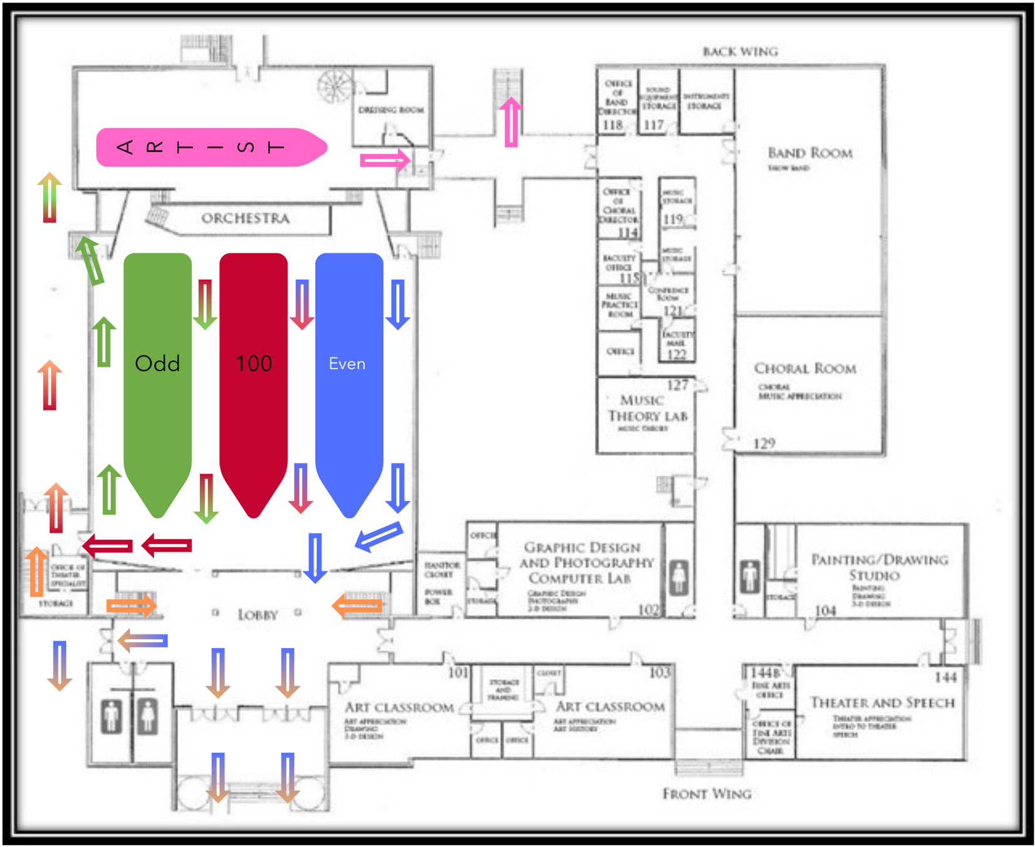

Classroom Evacuation

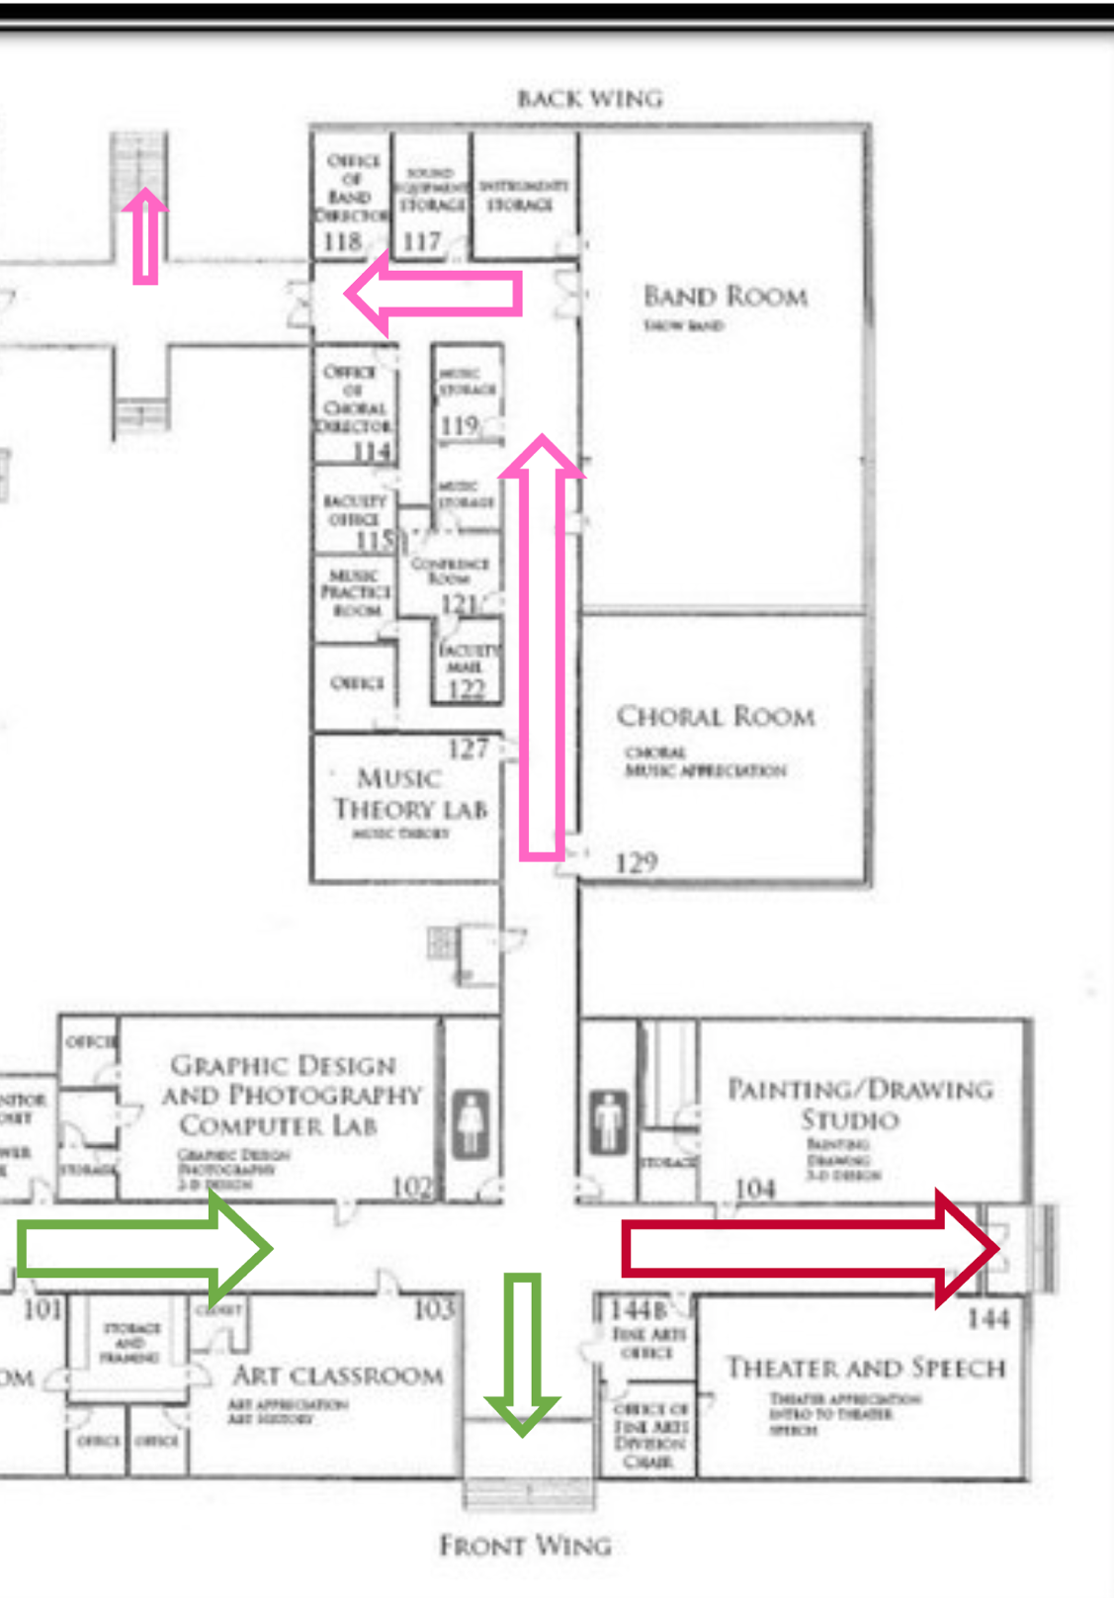

APPENDIX B: FIRE EXTINGUISHER LOCATIONS
Fire Extinguisher Usage:
If a fire is encountered early enough that it may be practical to fight using a hand-held extinguisher, the method is best remembered using the acronym “PASS” as follows:
- Pull the pin
- Aim the extinguisher at the base of the fire
- Squeeze the handle to activate the extinguisher
- Sweep the base of the fire until it is suppressed

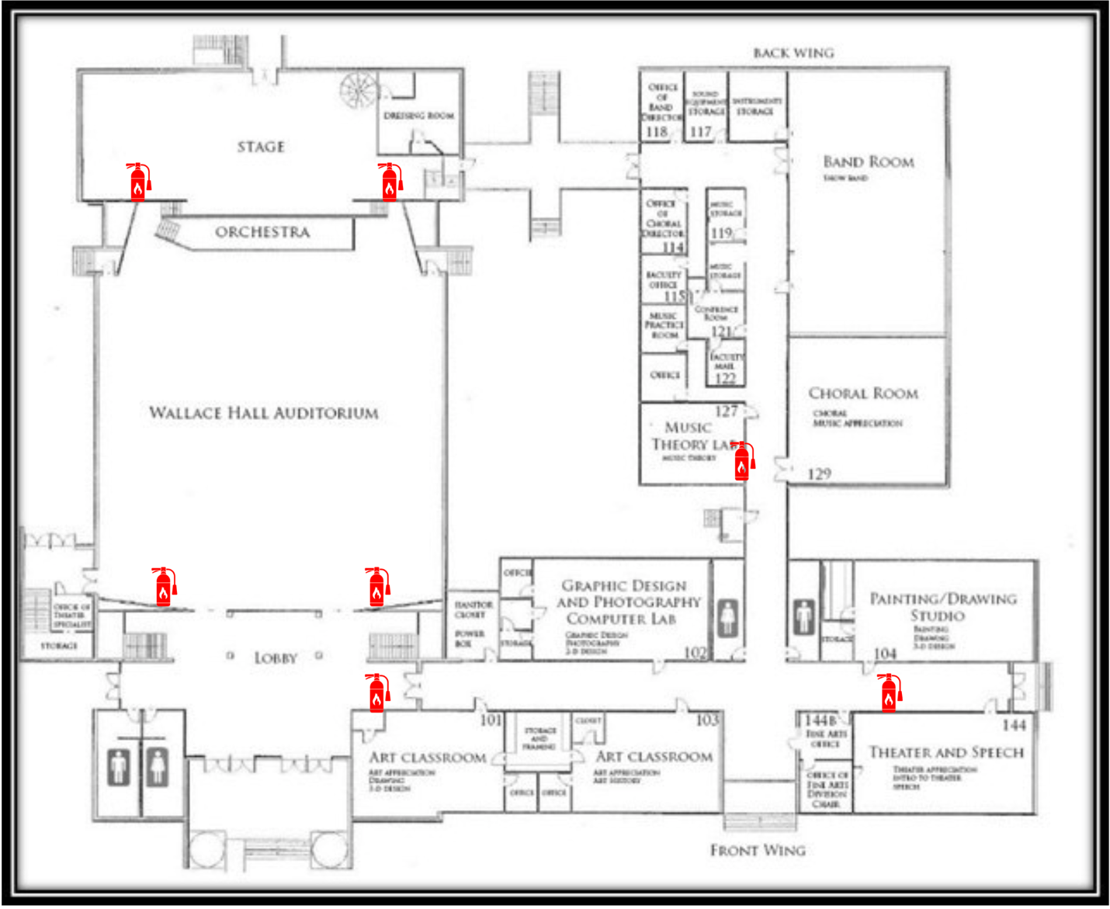

APPENDIX C: SHELTER LOCATIONS
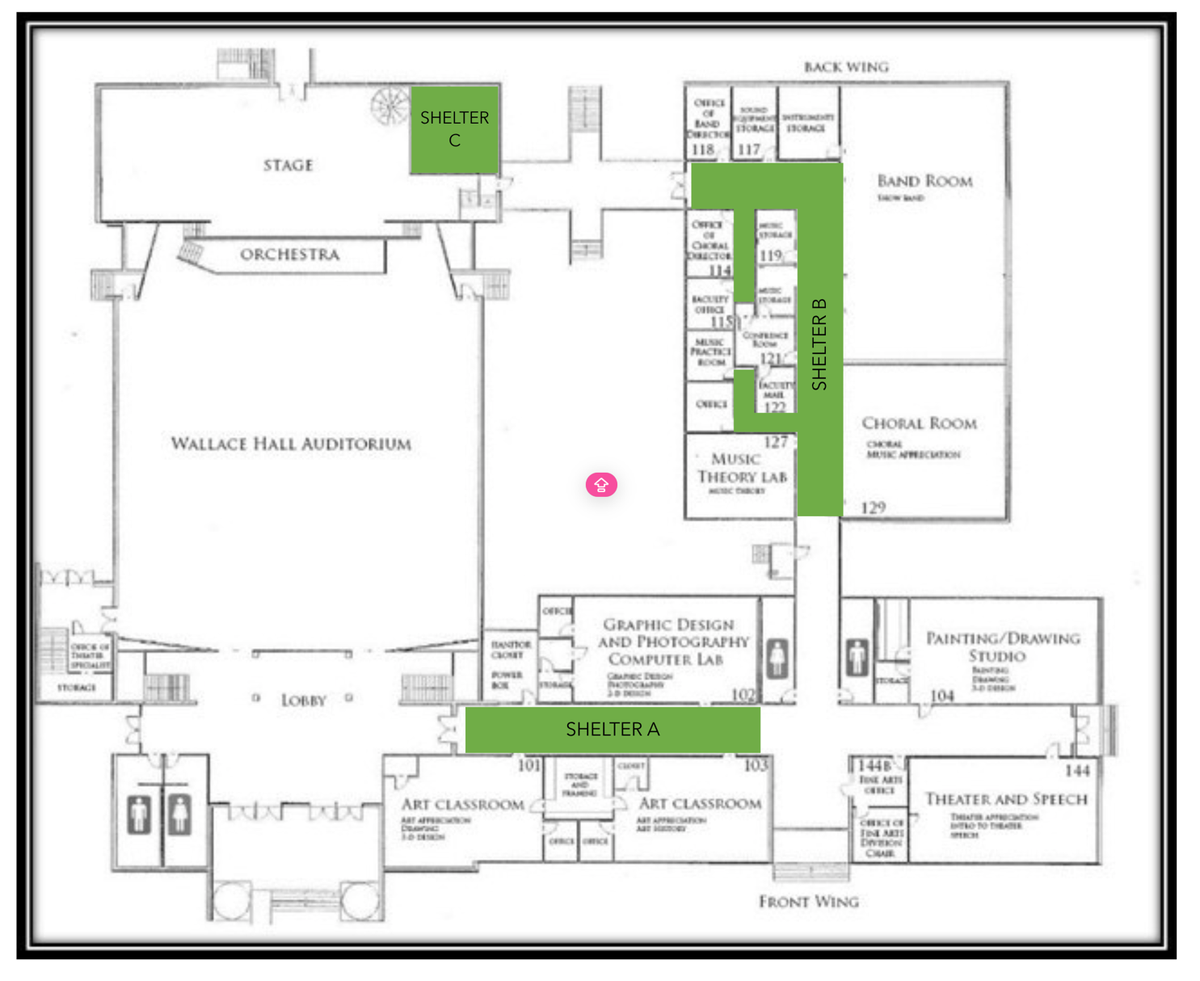

APPENDIX D: CALLING CHAIN
If your name appears in the first column on the left, you should make sure you have the cell phone numbers of those you are to contact in an emergency situation.
Theatre Manager -------------------------------------------------------------------------------------- Division Chair
Technical Director
Box Office Manager
House Manager
Renter/Artist Org
Sponsors/Donors
Security/PD

Division Chair ---------- --------------------------------------------------------------------------------- GSCC Dean
GSCC Admin

Technical Director --------------------------------------------------------------------------------------- Technicians
Backline/Rental Orgs
Artist

Box Office Manager ------------------------------------------------------------------------------------- Volunteers
Patrons

House Manager -------------------------------------------------------------------------------------------- Concessions Staff
Event Staff

Important Numbers:
Emergency: 911
24 Hour Non-Emergency Security: (256) 312-2132

Nearest Hospitals:
Gadsden Regional Medical Center (24 Hours)
(256) 494-4000
1007 Goodyear Ave
Gadsden, AL 35903

Riverview Regional Medical Center (24 Hours)
(256) 543-5200
600 S 3rd St.
Gadsden, AL 359
APPENDIX E: FIRST AID CARE
Remember the 3 Ps:
- Preserve Life
- Prevent Further Injury
- Promote Recovery
Check the scene for danger & hazards

CUTS & SCRAPES: Prevent blood from leaving their body
- Find a clean cloth or bandage.
- Apply gentle pressure for 3-8 minutes.
- Clean the wound by running clean, cool water over it. Avoid using soap on an open wound.
- Apply an antibiotic to the wound.
- Cover the wound with a cloth or bandage
NOSE BLEEDS:
- Have the person lean forward
- Press a cloth against the nostrils until the blood flow stops
DEEP WOUNDS:
- Apply pressure
- Don’t apply ointments
- Cover the area with a loose cloth to prevent contaminants from infecting the wound.
- Seek medical attention as soon as possible
SPRAINS:
- Keep the injured limb elevated
- Apply ice to the injured area. Don’t apply ice directly to the skin, use a cloth or ice in a plastic bag.
- Keep the injured area compressed. But it in a brace, or tightly wrap the injured area
- The injured person should avoid putting weight on the injured limb
HEAT EXHAUSTION:
- Get the person to a shaded area, out of the sun
- If no shaded place is available, keep the person covered with any available materials that can block sunlight
- Give the person water and keep them hydrated
- Place a cool cloth on their forehead to lower their body temperature.
Symptoms include:
- Cool, moist Skin
- Heavy sweating
- Dizziness
- Weak pulse
- Muscle cramps
- Nausea
- Headaches

BURNS:
Identify the type of burn:
- First-degree burn (minor burn): Only the outer layers of skin are burnt. Skin is read and swollen, looks similar to sunburn.
- Second-degree burn (major burn): Some of the inner layers of skin is burnt. Look for blistering skin and swelling.
- Third-degree burn (major burn): All of the inner layer of skin is burnt. The wound has a whitish or blackened color.
- Fourth-degree burn (major burn): A burn that has penetrated all tissues up to the tendons and bones.
Minor Burn treatment:
- Run cool water over the afflicted area
- Don’t break any blisters
- Apply moisturizer over the area, like aloe vera.
- Keep the burned person out of sunlight
- Have the burned person take ibuprofen or acetaminophen for pain relief.
Major burn treatment:
- Call 911 & GSCC PD
- Do not apply ointments
- Cover the wound with loose materials to prevent contaminants from infecting it.
ALLERGIC REACTION:
- Call 911 & GSCC PD
- Keep the person calm
- Ask if they use an EpiPen and have one with them.
- Have the person lie on their back.
- Keep their feet elevated 12 inches.
- Make sure the persons clothing is loose so they are able to breathe.
- Avoid giving them food, drink, or medicine
- If appropriate, use an EpiPen (90 degree angle, outer thigh)
- Wait 5-15 minutes after using an EpiPen. If the allergic reaction isn’t subdued, a second dose may be required.
FRACTURES/BREAKS:
- Do not try to straighten the limb
- Use a splint or padding to stabilize the area and keep it from moving.
- Apply a cold pack to the area. (Don’t apply it directly to the skin. Wrap it in a cloth or plastic bag.
- Keep the limb elevated, if possible.
- Give the person an anti-inflammatory drug, like ibuprofen.
FIRST AID CHECKLIST
__ Anti-bacterial Wipes __Bandages/Band-Aids __Scissors __Splint
__Ibuprofen __Sling __Tweezers
__Acetaminophen __Burn Gel __Thermometer
__Gauze Pads __Antibiotic Ointment __Breathing Barrier
__Sunscreen __Antiseptic Wipes __Instant Cold Pack
__Medical Gloves __Safety Pins __Cloth Tape

APPENDIX F: INCIDENT REPORT
Wallace Hall Fine Arts Center
Notice of Incident or Claim
TO: Division of Fine Arts Chair Date of Occurrence: __________________
CC: Dean of Academic Programs & Services Time of Incident: _____________________
Human Resources & GSCC PD Location of Incident: __________________
Persons Involved- Give name of any Wallace Hall employee or employees involved and the names, addresses, and phone numbers for any other persons involved.
Employee(s) Involved: _________________________________________________________________________________________
Other Persons Involved in Incident: ___________________________________________________________________________________________________________________________________________________________________________________________________________________________________________________________________________________________________
Description of Incident or Claim: ____________________________________________________________________________________________________________________________________________________________________________________________________________________________________________________________________________________________________________________________________________________________________________________________________
Was GSCC Employee Injured? Yes or No
Was other party injured? Yes or No
GSCC Vehicles or Property Involved: __________________________________________________________________________________________________________________________________________________________________________________________________
If Sever Damage Occurred, was an accident/offense report filed with police agency? Yes or No
Other Person(s) Vehicle or Property Involved:
__________________________________________________________________________________________________________________________________________________________________________________________________
Witness to Incident: ________________________________________________________________________________
Information Completed by: ___________________________________________________________________________
This report must be filed within 24 hours of incident occurring.
Immediate Corrective Action Taken: ____________________________________________________________________________________________________________________________________________________________________________________________________________________________________________________________________________________________________________________________________________________________________________________________________
Department Head or Supervisor of Employee Involved: _____________________________________________________
APPENDIX G: STAFF EMERGENCY CONTACT
DEANDRA BUSBY: DOB July 9, 1990
Director of Operations and Programming
Contact 1: Marlene Busby (Mom) (256) 689-8771
Contact 2: Miranda Busby (Twin) (256) 453-4970

BUFFY BAILEY: DOB: Sept 30, 2003
Box Office Manager
Alicia Bailey (Mom) (256) 557-2273
Cole Bailey (Brother) (256) 494-7753

COLE BAILEY: DOB: Sept 30, 2003
Technician
Alicia Bailey (Mom) (256) 557-2273
Buffy Bailey (Sister) (256) 494-7764

ELAINA CREEDON: DOB: July 18, 1995
House Manager
Michael Creedon (Husband) (256) 570-4434
Julie Anderson (Mom IL) (256) 393-7696

RYAN KELLY: DOB July 6, 2004
Technician
Kim Martin (Mom) (256) 399-2066
Kenneth Beck (Granddad) (256) 312-0993

AKSEL MCBRIDE: DOB April 10, 2007
Technician
Contact 1: Samantha Aldrich (Mom) (256) 300-3013
Contact 2: William “Lamar Stucki” (Step Dad) (777) 895-7497

ANDRE PATTERSON:
Show Band Tech

PHOENIX RICH: DOB: Feb 8, 2006
Technician
Cathy Reeves (Grandmom) (256) 390-6532
Ralph Reeves (Granddad) (256) 390-7636

DYLAN “KIRBY” ROGERSON: DOB: Aug 27, 2006
Technician
Amy Blankenship (Mom) (256) 944-0971
Hunter Rogerson (Brother) (256) 944-0973

AFTON YARNELL: DOB Aug 29, 2006
Technician
Jennifer Yarnell (Mom) (727) 277-1392
Andy Yarnell (Dad) (727) 992-0348

Emergency Management Resources

- ArtsReady (www.artsready.org)
- Building an Emergency Plan: A Guide for Museums and Other Cultural Institutions, Dorge/Jones
- GSCC, Alabama Emergency Operations Plan
- GSCC Fire Department, Assistant Chief: Ben Stewart
- GSCC Human Resources & Safety Department: Marc Webb
- GSCC: Pandemic Recovery Safety Policy
- GSCC Police Department: Captain Chip Owens, Sergeant Tom Bradley
- Cultural Peacekeeping Guide, CERF+ & South Arts (www.cerfplus.org) (www.southarts.org)
- Eastern Kentucky University, Richmond Campus: Building Emergency Action Plan, Center for the Arts
- Effective Emergency Management: A Closer Look at the Incident Command System, Brian Bennett
- The Event Safety Alliance Reopening Guide (www.eventsafetyalliance.org)
- Federal Emergency Management Agency (FEMA), Etowah County Hazard Mitigation Plan (www.fema.gov)
- Federal Trade Commission, Protecting Personal Information: A Guide for Business (www.business.ftc.gov)
- International Alliance of Theatrical Stage Employees (IATSE), Stagecraft Safety Committee (www.iatse.net)
- Management Wise: How to Develop an Emergency Management Plan: Jones, CRM, Keyes
- National Coalition for Arts, Preparedness and Emergency Response (NCAPER)
- Occupational Safety & Healthy Administration (OSHA): Evacuation Plans and Procedures (eTool) (www.osha.gov)
- OSHA: Guidance on Preparing Workplaces for COVID-19 (www.osha.gov)
- Open for Business: Employee Awareness, Training, & Exercises: Institute for Business & Home Safety
- Performing Arts Readiness, Plans and Tools (www.performingartsreadiness.org)
- Sample Emergency Plan from Arts Education Center
- U.S. Department of Homeland Security, Active Shooter: How to Respond (www.dhs.gov)
- Arts Emergency Management: Building Your Disaster Plan, University of Kentucky Department of Arts Administration, Leah Hamilton
- The Art of Reopening: A Guide to Current Practices Among Arts Organizations During COVID-19 – National Endowment for the Arts (arts.gov)

